

Capital University of Science and Technology

Department of Computer Science

|  |  |
| --- | --- |
| CS2523 – Computer Organization and Assembly Language  **ASSIGNMENT NO. 1: Instruction Cycle, Number Systems**  **CLO: 1.** Define concepts in the design of microprocessor as state machine and designing its data path and its controller. [C1- Remembering]  **CLO: 2.** Describe how the basic units of the Intel 8088 architecture work together to represent Integer Numbers, Floating Numbers and register representation inside the microprocessor. [C2- Understanding] | |
| **Semester:** Fall 22 | **Max Marks:** 10 |
| **Instructor:** Ms. Tayyaba Zaheer    **Assigned Date:** October 10, 2022 **Due Date:** October 15, 2022 | |
| **Name:** | **Reg. No.** |

**Guidelines:**

You are required to submit the **screenshots of code and output of the program (where required) and concepts in your own words i.e. must be hand written** in theassignment file (word or pdf – pictures attached must be readable and in portrait mode) as **courseCode_studentReg#_studenName** via Microsoft Teams.

**Important Note:**

1. Must not copy from other students, so do it all yourself.
2. Assignment should be hand written.

**Objectives:**

After completion of this Assignment, you will have gained basic knowledge of computer organization and assembly. You will be able to understand different data representation techniques used in computers.

**Data Representation: Topic:** Number Systems, and Conversion between Decimal, Binary, Hexadecimal, and other bases. **Related Reading:** Class Lectures and Reading Material Shared with the assignment.

**Tools/Software Requirement (Optional):**

1. Microsoft Word.
2. emu8086.

**Description:**

**Emu8086** is an 8086-microprocessor emulator and disassembler. Emu8086 permits to assemble, emulate and debug 8086 programs (16bit/DOS).

**Tasks:**

**Task#1: Instruction Cycle: (02 marks)**

**Question:** Elaborate 5 sub-operations of the control unit in the given scenario of Instruction Cycle:

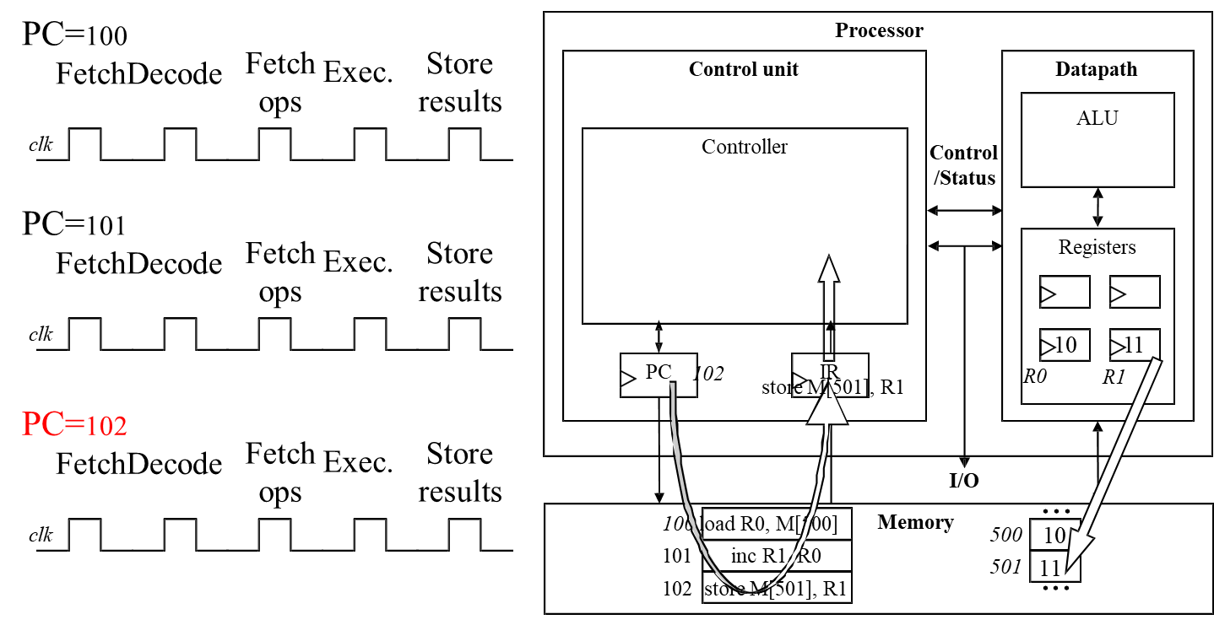

**Task#2: Number systems: (06 marks)**

**Question#1:** Convert Decimal 25 to binary:

**Question#2:** Convert Decimal 451 to octal form:

**Question#3:** Convert Decimal 146 to hexadecimal:

**Question#4:** Convert Binary 010111012 to decimal number:

**Question#5:** Convert Binary 10101012 to octal:

**Question#6:** Convert Binary 00010111 in hexadecimal number:

**Question#7:** Convert Octal 57468 to decimal:

**Question#8:** Convert Octal 278 to a binary number:

**Question#9:** Convert Octal 10028 to hexadecimal:

**Question#10:** Convert Hexadecimal CA16 to decimal:

**Question#11:** Convert Hexadecimal A2B16 to binary:

**Question#12:** Convert Hexadecimal 10516 to octal:

**Task#3: Read the file “A01ReadingMaterial” shared with this assignment and answer the following questions: (02 marks)**

**Question#1:** What are decimal, binary, octal and hexadecimal systems?

**Question#2:** Write the generic way to convert from decimal system to any other:

**Question#3:** Write the generic way to convert from any other system to decimal:

**Question#4:** How signed numbers can be represented? How overflow could happen in the given scenario of subtraction of two numbers?

**Question#5:** In emu8086, how you could access the handy tools to convert numbers? Differentiate between Base converter and Multi base calculator. What type of operations are supported or allowed?